Draft Report of the National Expert Group on MSFD Descriptor D4 – Food Webs (SEGFW)
Innehållsförteckning
Executive summary 2
Introduction and Expectations 2
Background and Rationale for SEGFW 2
A Food Web Primer 3
Expectations for the Swedish Expert Group on Food Webs 3
Policy and Management Needs for Food Web Indicators 4
EU MSFD Decision on D4 and Swedish national legislation 4
Review of Indicators Selection: OSPAR, HELCOM, and National 6
OSPAR 7
HELCOM 7
National 8
Selection of appropriate operational Food Web Indicators, OSPAR, HELCOM, National 9
Roadmap for future development of D4 Food Web Indicators 10
Active engagement of Swedish FW experts in the development, testing, and operational phase of FW indicators within OPSAR, HELCOM and at the National level. 11
Regional and Cross-regional coordination, and availability of suitable data at the regional sea level 11
Information flow between FW indicators experts: Gaps, overlaps, and caveats 11
Ecological thresholds, uncertainty and GES 11
Integrated assessment and uncertainty 12
Further steps in FW indicators development considering food webs, multi-species, and ecosystem models 12
Recommendations (Andrea + All) 13
Choosing current FW indicators 13
Perspective for future FW indicators development and Timelines 13
References 14
Annex 1: List of participants 14
Annex 2: Terms of Reference 14

Executive summary
The National Expert Group on MSFD Descriptor D4 – Food Webs (SEGFW) has evaluated the current status and development of operational indicators for Descriptor 4 (Food Webs), according the Commission Decision (EU) 2017/848. The SEGFW has evaluated (i) the operational food web indicators within OSPAR, HELCOM, and at the National level, (ii) compiled information on available models for Swedish waters that can be used to evaluate and develop food webs indicators, and (iii) identified knowledge gaps providing a roadmap for further indicator development of food webs indicator beyond 2018, as a reference guide for SwAM. The report further suggest regional and cross-regional integration of food webs indicators and make them operational, to meet the requirement of the Marine Strategy Framework Directive and the Regional Seas Conventions.

Introduction and Expectations

Background and Rationale for SEGFW
The EU Marine Strategy Framework Directive 2008/56/EC (MSFD) requires the member states of the European Union to achieve good environmental status (GES) in their marine waters using 11 Descriptors by 2020. Of those, Descriptor 4 (D4) focuses on the marine food webs: “All elements of the marine food webs, to the extent that they are known, occur at normal abundance and diversity and levels capable of ensuring the long-term abundance of the species and the retention of their full reproductive capacity”.

Food webs can be described as a network of trophic feeding interactions across level of biological organization among species or populations that characterize ecological communities and ecosystems. Considering that marine food webs are strongly size-based (Sheldon et al., 1972; Kerr and Dickie, 2001), in recent years the link between food web dynamics and ecosystem functioning has been based, for example, on the energy transferred between trophic levels and biomass consumption rates of different species assemblages, to provide an energy budget representation of food webs. The information provided by this approach of aggregating species has been used to study the ecosystem adaptability to respond to different types of pressures including anthropogenic changes via commercial fishing, bottom-up effects such as variability in nutrients supply, and top-down effect like changes in predations pressure.

The D4 indicators specified in the European Commission Decision (2010/477/EU) and the recent Commission Decision (EU) 2017/848, repealing Decision 2010/477/EU, address three criteria related to food web structure and energy flow between different components (see Table 1). However, in 2015, ICES WKGMSFDD4-II (Report of the Workshop on guidance for the review of MSFD decision descriptor 4 – foodwebs II, ICES 2015), suggested to use the concept of trophic guilds (defined as is any group of species that exploit the same resources) instead of species for the categorization of food webs to obtain criteria more closely related to the important aspects of food web: structure, function, and resilience (ICES 2015).

Development of simple food web indicators, which are able to evaluate the health of highly dynamic and complex interactions, is challenging. Thus, the Swedish Expert Group on Food Webs (SEGFW) was created in order to provide SwAM with guidance in the current development of D4 indicators within the EU MSFD and the expectations to engage Swedish food web experts in the development of D4 indicators for Swedish waters and contribute to the work in progress within OSPAR, HELCOM, ICES, and at the National level. Furthermore, the group will facilitate the assessment of food webs under the Marine Strategy Framework Directive (MSFD) (Table 1).
Main key issues that the group should address:
- Possibilities to describe and assess the state of pelagic and benthic food webs in Swedish marine areas to be integrated in the national initial assessment in 2018 for MSFD reporting issues.
- Develop a roadmap (including prerequisites) to improve future assessments of pelagic and benthic food webs in Swedish marine areas.
- Ensure international cooperation and coordination.
- Coordinate in cooperation with SwAM, the work needed to assess food webs in the future (beyond 2018).
Tabell 1 Assessment structure of the MSFD related to the Swedish Expert Group on Food Webs.
Assessment Level | Responsible Body | Comment
MSFD Descriptor Level | Swedish Food Web Group | According to the latest recommandation of EU Comission. The cirteria, except of D4C1 (see table 5) should be integrated upp to the trophic guild level. This would imply no integrated assessment of all criteria at descriptor level (for further explanation, see section XXXX).
MSFD critreria Level | Swedish Food Web Group | Criteria: In theory this level integrates several indicators covering one trophic guild (for details see chapter ” 2.1 EU MSFD Decision on D4 and Swedish national legislation” in this document). The criteria might be assessed at different spatial scales, e.g. sub-basins. Thresholds for Good Environmental Status might be set at this level, to indicate changes in the ecosystem (surveillance indicators). Since the indicator set up will not be complete and might never be complete we would need an expert judgement for the assessment at this level, if possible with the help of the results from l the indicator level.
Indicator Level | RSCs Expert Groups | Indicators: this level will be assessed with the help of HELCOM fact sheets or OSPAR assessment sheets. The indicators described ´parameters of specific communities or trophic guilds, e.g. mean size and total stock zooplankton; pregnancy frequency of seals; size composition of the fish community. These indicators might be assessed with the help of specific thresholds. Integration of indicators up to the next level might be possible but unlikely because gaps in the indicator setup, both spatial and thematically. Assessment at this level will be done mostly by expert groups within HELCOM and OSPAR

The group is coordinated in cooperation with The Swedish Authority for Marine and Water Management (SwAM) and the Swedish Institute for the Marine Environment (SIME). The group has no direct link to any regional sea convention as OSPAR or HELCOM, but may contribute to the assessment of food webs on this level, if needed.

Expectations for the Swedish Expert Group on Food Webs (SEGFW)
There were three main expectations for the SEGFW:
- To suggest a short list of Food Web Indicators linked to the MSFD Descriptor 4 that may be used by Sweden to report to the EU in 2018
- To provide a procedure for selecting and further develop such indicators
- To suggest the integration of food web indicators in order to assess temporal and spatial changes in the food web dynamics of the Baltic Sea
This approach led to the adaptation of an identification and evaluation method based on ICES WKFooWI (ICES 2014), and to make a preliminary selection of food web indicators that can be estimated from available models (modified from ICES WGSAM 2013). We then further elaborate to provide guidance for the initial assessment of food webs in 2018 for the MSFD, and suggest a roadmap for further development of food web indicators.
Policy and Management Needs for Food Web Indicators

EU MSFD Decision on D4 and Swedish national legislation
The implementation of the MSFD is regulated by the Commission Decision (EU) 2017/848. The decision was revised and a new draft version was published in May 2017. A criteria can now be defined as primary (mandatory for reporting) or secondary (not mandatory) . The revised commission decision combines the assessment of ecosystems and food webs now in Descriptor 4 (D4). The revised commission decision states that D4 shall describe functional aspects of the ecosystem whereas D1 (Biodiversity) addresses the position of functional groups (e.g. pelagic feeders within the element bird) in the ecosystem structure. Descriptor 4 contains two primary and two secondary criteria (Table 2). Furthermore it is defined that every criteria as long as reported, should assess at least three different trophic guilds (ref to ICES 2015), where one of these should be non-fish. Furthermore it is recommended that the bottom, middle and top levels within the food web are represented. The trophic guilds that are assessed in a certain region (e.g. Baltic Sea) should be defined by regional coordination to ensure comparability between countries. However, no such discussions are started yet and it is unlikely that regional coordination will be finished before the reporting deadline in 2018. Therefore, national assessment should be used.
According to the revised Commission decision shall all criteria in D4 be assessed against a threshold. The assessment is done against a regional threshold (threshold which is valid in a whole region, e.g. Baltic Sea or per sub-basin if necessary), which again call for regional coordination and the development of surveillance indicator beyond 2018. If a threshold is not met, this would trigger further research in order to find the driving factors behind it, so the indicators used for assessing the criteria in D4 are still classified as “surveillance indicators”. The assessment of D4 is expected to be sensitive to overall changes in the ecosystem but not to specific anthropogenic pressures. The geographical scale for the Baltic Sea would be region (whole Baltic Sea), or sub regional for the North-East-Atlantic. Subdivisions (i.e. basins) might be used for the assessment if ecological relevant. The geographical scale may be adjusted in relation to the progress in the development of operational food web indicators and data availability beyond 2018.
Tabell 2 The four Criteria of Descriptor 4 in the revised Commission decision (Com 2010/477/EC)
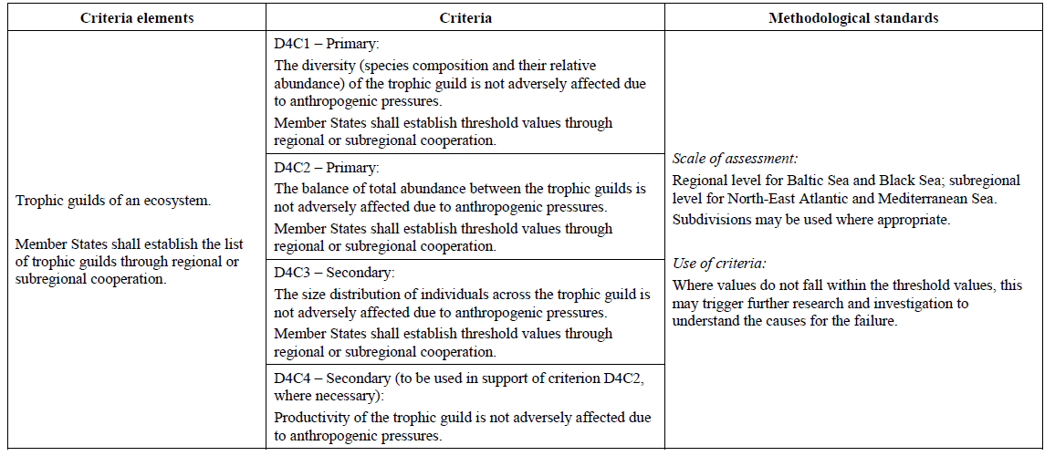The decision is not specific about how these criteria should be integrated in order to provide a holistic assessment of food webs in European Seas. However, there is an ongoing discussion to draft a guidance document for the article 8 reporting (State of the environment). The draft presented now aims for an integration of indicators and criteria into trophic guilds (figure 2). No integration of trophic guilds has to be done. This might be specified during spring 2017 by further discussions within the Working Group on Good Environmental Status (WG GES).
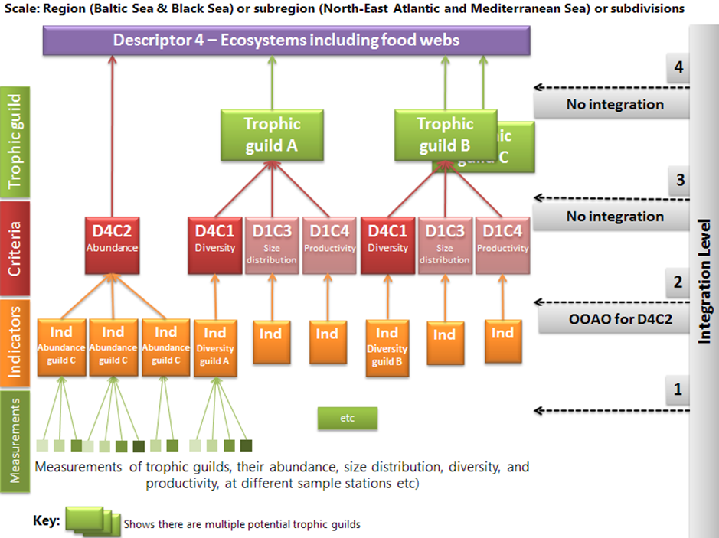
Figure 1. Possible integration of food web indicators. The highest level of integration is the respective trophic guild. Figure is taken from the proposal of EU WG GES article 8 guidance, figure might be changed after further discussion at EU level. (Ind = Indicator; OOAO = One out all out; Ind – Indicator; Criteria in red – mandatory; Cirteria in pale red – not mandatory; D4C1 & D4C2 see table 2; D1C3 – Demography criteria within Descriptor 1 which might describe size distribution; D1C4 mistake, should be D4C4 Productivity (picture taken from WG GES report for the 16th meeting of ther Working Group on Good Environmental Status (WG GES).
Further, food web indicators will also be considered under the Data Collection Multi-Annual Plan (DC-MAP), and Common Fisheries Policy (CFP).

Trophic Guilds
Following the four Criteria for D4 based on the revised Commission decision (COM 2010/477/EC) and the adoption of the Trophic Guilds (TG) concept for FW indicators (ICES 2015), the indicators that have been evaluated in this report should also consider this TG concept. For this reason it is of interest to revisit the TG concept (ICES 2015) as a general guideline.
Tabell 3 Example of Trophic guilds. X denotes the taxonomic groups that contribute to each guild. Nekton includes bony fish, elasmobranchs and squid. Marine microbes represent lower trophic level and Macrophytes represent shallow waters habitats. (Table 2 modified from ICES 2015).
Guild\Taxonomic group | Marine Microbes | Phytoplankton | Zooplankton | Periphytic algae | Benthos | Macrophytes | Nekton excl.  warmblooded | Seabirds | Marine mammals
Primary producers | X | X |  | X |  | X
Secondary producers | X |  | X
Filter-feeders |  |  |  |  | X
Deposit -feeders |  |  |  |  | X
Planktivores | X |  |  |  | X | X | X | X
Sub-apex pelagic predators |  |  |  |  |  |  | X | X | X
Sub-apex demersal predatorss |  |  |  |  | X |  | X | X | X
Apex predators |  |  |  |  |  |  | X | X | X

National legislation – status quo
So far the SwAM regulation HVMFS 2012:18 (Havsmiljöförordningen) lists seven food web indicators. The indicator setup was designed according to the original commission decision 2010/477/EC. This regulation has to be updated according to the setup of indicators in 2017 as a result of this report. The listed indicators can be found in the indicator section, mostly the indicators listed in HVMFS 2012:18 are identical with food web indicators developed in OSPAR and HELCOM available at that time, but it might be possible that Sweden choose to use national indicators as far as no regional coordination for the assessment of D4 has been done.

Review of Indicators Selection: OSPAR, HELCOM, and National
There is a need to assess more directly key features of marine ecosystems in a more integrative fashion. Food web indicators provide information on key aspect of ecosystem functioning and structure (Shin et al. 2012; Link 2005; Rice & Rochet 2005; Samhouri et al. 2009) that need to be considered for the development of measures (Article 13) aiming to promote Good Environments Status (GES Article 9) for the EU marine waters (MSFD 2008/56/EC).
In order to review and rank the D4 indicators currently under development within OSPAR, HELCOM, and in Sweden, SEGFW have adopted the approach developed by ICES WKFooWI (ICES 2014) and Tam et al. 2017. Here we evaluate the indicators using analytical criteria adjusted from the extensive work by ICES WGBIODIV (ICES 2014b), ICES WGECO (ICES 2013a) and the input from ICES WGSAM (ICES 2013b). The review of the D4 indicators is presented in Tables 3 and 4. Food web indicators were grouped by attribute and against criteria listed in Table 3.1 (ICES WKFooWI (ICES 2014a), and the ranking applied was 0= not met, 1= partially met, 2= fully met as reported in Table 6 (modified from ICES 2014a). The selection criteria, which are based on internationally recognized best practices and follow generally accepted protocols (ICES 2014a), are based on the Delphi method approach using expert knowledge (Norman & Olaf 1963). The ranking of the food web indicators was expressed as a percentage of the total available score (i.e. max score x number of categories, 2 x 13 = 26). It was taken into consideration how well the indicators represents the main attributes of food webs such as Functioning, Resilience and Structure (ICES 2014a).

OSPAR
The following D4 indicators are under development within OSPAR. The indicators highlighted in yellow will not contribute to the OSPAR IA2017, (OSPAR ICG-COBAM 2015).
Table 3 OSPAR indicators available January 2017.
Indicator namE | Indicator status | Assessed in IA 2017 in OSPAR region | Link to HVMFS 2012:18 (table 4)
Reproductive success of marine birds in relation to food availability (FW1) | Candidate | Not assessed | No
Production of phytoplankton (FW2) | Candidate  (case study) | Region II, III, IV | No
Size composition in fish communities (FW3) | Common | Region II, III, IV | No
Changes in average trophic level of marine predators (cf MTI) (FW4) | Candidate | Region IV | No
Change of plankton functional type (FW5) merged with changes of plankton functional types (life form) index ratio (PH1) | Common | Region II, III, IV | No
Biomass, species composition and spatial distribution of zooplankton (FW6) | Candidate | Not assessed | No
Fish biomass and abundance of dietary functional group (FW7) | Candidate | Not assessed | No
Biomass trophic Spectrum (FW8) | Candidate | Not assessed | No
Ecological Network Analysis diversity (FW9) | Candidate | Not assessed | No

HELCOM
The D4 related indicators currently developed within HELCOM (HELCOM 2013) that will contribute to the HELCOM HOLAS II assessment 2017 are listed below:
Table 4. HELCOM indicators available January 2017.
Indicator namE | Indicator Status | Use in HOLAS II | Link to HVMFS 2012:18 (table 4)
Zooplankton mean size and total abundance (Gorokhova et al. 2016) | Core | Yes | Not yet - Will be included in update 2017
Proportion of large fish in the community | Core | Propably Descriptive | No
Ratio of diatoms and dinoflagellates | Core | Case study | Not yet – if suitable update in 2017
Phytoplankton community composition as a food web indicator | Core | No | No
Seasonal succession of functional phytoplankton groups | Core | No | No
Zooplankton-phytoplankton biomass ratio | Candidate | No | No
Nutritional status of seals | Core | Yes | 4.1B
Reproductive status of seals | Core | Yes | Not yet - Will be updated in 2017
Abundance of coastal fish key functional groups | Core | Yes | 4.3A

National
The following FW indicators were evaluated using the selection criteria as described above:
- FoodWeb evenness index (FEW) – accounts for energy loss and biomass at higher trophic levels (ICES 2016)
- Abundance of coastal fish key functional groups
Size distribution of coastal key species (1.3E HVMFS 2012:18)In a previous report at the National level (God havsmiljö 2020, del 1), food webs were described qualitatively and no assessment was done against threshold in the 2012 reporting cycle. According to HVMFS 2012:18 (Table 2), the following indicators were assigned to food webs:
Table 5. Overview of the indicators listed in the SwAM regulation (HVMFS) 2012:18 (direct translation from Swedish). This regulation will be updated during 2017 according to the suggestions presented in this report, this will even included a revision of the “Thematic area” column to align the regulation with the revised Commission decision (COM DEC 477/2010). Last update of the regulation was done in 2014. A detailed description of these FW indicators is available in the annex 2 of GES
Thematic area | Indicator | Assessment area | Functional from
4.1 Productivity (production per unit biomass) for key species or trophic key groups | 4.1A Productivity of sea eagle | All coastal water types in the Baltic Sea | 2012
 | 4.1B Growth of marine mammals | Not defined yet | 2016
4.2 Proportion of selected species at top of the food web | 4.2A Size structure of coastal fish key species | Not defined yet | 2018
 | 4.2B Size structure of coastal fish functional groups | Not defined yet | 2018
4.3 Abundance and distribution of trophic key groups or species | 4.3A Abundance or biomass of important coastal fish functional groups | Not defined yet | 2016
 | 4.3B Trophic level within the coastal fish community | Not defined yet | 2018
 | 4.3C Abundance of non-breeding birds | Not defined yet | 2016 (Baltic Sea)  2018 (North Sea)

Case study – pelagic food web in the Baltic
Other pelagic food web indicators are currently developed for the Baltic Sea within the project “Ecosystem-based approach for developing and testing pelagic food web indicators” (Torres et al. 2017; Otto et al. 2017). These pelagic food web indicators are based on two and three trophic level set-ups including environmental drivers and fishing pressure as outlined below in Fig. 3.

two trophic level set-up three trophic level set-up
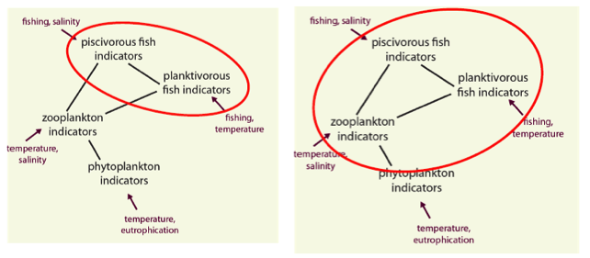
Fig. 3. Baltic Sea pelagic food web indicators development using a two and three trophic level set-up (Torres et al., 2017). Marine mammals (population size, age structure, spatial distribution and species distribution) can be incorporated as increased size-dependent mortality. In addition, the trophic levels below zooplankton will be modelled in greater detail in linked sub-models. Moreover, indicators of extent of spatial distribution, both for demersal and pelagic ecosystem, are under development under different Swedish projects (Torres et al., 2017).
Selection of appropriate operational Food Web Indicators, OSPAR, HELCOM, National
The selection of appropriate D4 indicators may be based on the evaluation presented in Table 6 (Criteria used to evaluate Food Web indicators based on those developed by ICES WGECO 2013a and modified by ICES WGBIODIV 2014b and reported by ICES WKFooWI 2014a). The spatial scales of assessment will be determined in relation to the EU MSFD, OSPAR and HELCOM assessment scales, the Regional Sea Conventions and at the National level.
The evaluation of the indicators using analytical criteria adjusted from the extensive work by ICES WGBIODIV (ICES 2014b), ICES WGECO (ICES 2013a) and the input from ICES WGSAM (ICES 2013b) is presented in Table 5. The scoring outcomes reflected the current use of the specific indicators applied to a specific ecosystem component, a low score may reflect that the specific indicator needed more time to be developed to become fully operational. The Food Webs (FW) indicators that will be contributed to the OSPAR IA 2017 Assessment, the HELCOM HOLAS II Assessment 2018, and some potential National FW indicators that may contribute to the MSFD 2018 Report were ranked according to the selection criteria, as previously described, and scored using the Delphi method (ICES 2014a). The score also reflected the three main food webs attributes considered, e.g., Function, Structure and Resilience (ICES 2014a). The four OSPAR FW indicators: Production of phytoplankton (FW2), Size composition in fish communities (FW3), Changes in average trophic level of marine predators (cf MTI) (FW4), and Change of plankton functional type (FW5) merged with PH1, scored relatively high against the assessment criteria and reflected all the three Food Webs attributes. This group of indicators was important to guide further development for operational food web indicators within the OSPAR maritime area.
With reference to the FW OSPAR indicators in relation to the assessment in Swedish waters, the Production of phytoplankton (FW2) OSPAR Assessment sheet includes data from the Skagerrak Coast, Tiselius et al. (2015); the Size composition in fish communities (FW3) OSPAR Assessment sheet also includes data covering both Kattegat and Skagerrak; for the Changes in average trophic level of marine predators (FW4) the OSPAR Assessment sheet includes data from France and Spain, however this indicators is based on the Mean Trophic Level (MTL) concept and for Sweden data are available to calculate this indicators (Hornborg et al. 2013).
The other OSPAR FW indicators that will not contribute to the OSPAR IA 2017 Assessment are currently being further developed under the EcApRHA project, e.g. FW6, FW7, and FW9, (OSPAR ICG-COBAM(2) 16/9/1, Annex 7, 2016).
Regarding the FW indicators that will contribute to the HELCOM HOLAS II Assessment 2018, two indicators: Zooplankton mean size and total abundance, and the Proportion of large fish in the community, scored high as an indication that these indicators will provide valuable information on the three main attributes of food webs. The remaining three FW indicators: Ratio of diatoms and dinoflagellates, Seasonal succession of functional phytoplankton groups, and Zooplankton-phytoplankton biomass ratio; scored lower indicating that further development of these indicators is necessary for being considered fully operational.
At the National level two FW indicators were evaluated: FoodWeb evenness index (FEW), and Abundance of coastal fish key functional groups; both indicators scored relatively high and reflected both the functional and structural attributes of food webs, and should be considered as potential FW indicators that can contribute to the MSFD 2018 Assessment at the regional level
The FW indicators evaluated in Table 5 represented most of the TG described, however specific FW indicators including Marine microbes and Macrophytes are currently lacking. The theoretical background for both the OSPAR and HELCOM selected food web indicators that contributed to the OSPAR IA 2017 Assessment and HELCOM HOLAS II Assessment can be found in the respective Reports.
Roadmap for future development of D4 Food Web Indicators
The proposed roadmap consider the following aspects:
- What need to be done for the development of current and future FW indicators in the light of the current information on the MSFD Descriptor D4 based on the revised Commission Decision (EU) 2017/848
- What are the necessary steps for the implementation of future work on FW indicators considering the timelines for both a short-term (2018) and long-term perspective (beyond 2018)?
Some of the most important issues to address in the roadmap were identified as:
- Active engagement of Swedish FW experts in the development, testing, and operational phase of FW indicators within OSPAR, HELCOM, and at the National level. Within OSPAR a Food Web working group is established but must even focus on the Wider North Sea. No such coordination group is present within HELCOM. SwAM should initiate such a group within the State & Conservation working group.
- Specifically securing participation of experts in the lower trophic levels bacteria, protozoa and phytoplankton (possibly also viruses).
- Regional and Cross-regional coordination, and availability of suitable data at a regional sea level, this may be achieved by more active participation for example in the ICES Working Group on Biodiversity and by initiating a more specific collaborative work on this aspect facilitated by ICES
- Information flow between FW indicator experts: Gaps, overlaps, and caveats
- Ecological thresholds, uncertainty, GES, and issues related to aggregation and spatial integration of FW D4 indicators
- Further steps in FW indicators development considering food webs, multi-species, and ecosystem models
- Revising the assessment structure for the MSFD within respective ICES working groups which fed in relevant updates and results from discussion to the WG GES. The aim of such discussion must be a more holistic assessment of food web, which focus on ecosystem models.

Active engagement of Swedish FW experts in the development, testing, and operational phase of FW indicators within OSPAR, HELCOM and at the National level.
Swedish FW experts have indicated the current engagement in the development of FW indicators with OSPAR, HELCOM, and at the National level (Table 3). At present, and considering a long-term perspective beyond 2018, the engagement of FW experts currently involved in the development of FW indicators need improvements. A closer link between FW experts needs to be established to prioritize future work for the development, testing, and operational phase on FW indicator. This requires also a closer collaboration between SwAM, the Institution responsible for the collections and availability of National data, and research projects that includes work related to food webs.

Regional and Cross-regional coordination, and availability of suitable data at the regional sea level
A closer cooperation is necessary between FW experts to facilitate the sharing of scientific knowledge for the development and implementation of D4 FW indicators within and between regions, and in relation to Article 8 of the current MSFD, providing a closer link with the activities within OSPAR, HELCOM, and ICES. As pointed out by WKFooWI (ICES 2014a), the current and future development of specific indicators depends on the availability of suitable data to address in particular the new D4 Criteria in relation to Trophic Guilds (TG). It is also important to agree on a suite of indicators that can be used to address common management actions at a regional seas scale.

Information flow between FW indicators experts: Gaps, overlaps, and caveats
FW indicators experts are encouraged to share scientific knowledge to develop further a common understanding of the type of food webs interactions related to specific indicators. For example, there is currently a lack of FW indicators considering low trophic levels (Fig.4), e.g., microbial community, and changes in the bacterio- to phytoplankton production (Wikner and Andersson 2012), and in relation to macrophytes benthic habitats (Baden et al. 2012; Moksnes et al. 2008; Infantes et al. 2016).

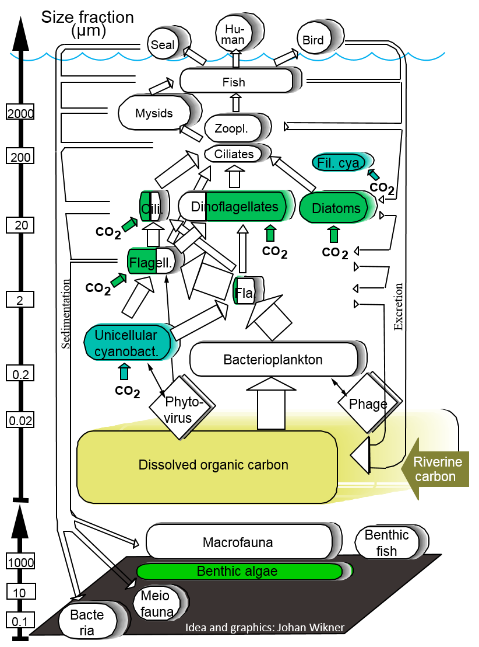
Fig. 4. A simplified sketch of the marine food web indicating approximate size distribution of organisms. The lower part of the food web is emphasized, but also realistically presents its relative importance in terms of transformation of energy and materials on the Sea. Partly green boxes indicate mixotrophic organisms using both light and organic compounds as energy sources. Abbreviations are: Zoopl.=Zooplankton, Cili.= Ciliates, Fi. Cya= Filamentous cyanobacteria, Flagell. and Fla. =Mixotrophic and heterotrophic flagellates, respectively. Modified from original published in Kuparinen et al. 1996, Ambio special report No. 8.
Further development of FW indicators considering the Trophic Guilds (TG) concept (ICES 2015) and develop other approaches for determining trophic guilds such using information provided by habitat types. FW experts should also consider the overlaps and integration of indicators in providing relevant information for the assessment of food webs and describe any caveats in relation to the operational aspect of each indicator to be used for management purposes.

Ecological thresholds, uncertainty and GES
At present, it is not possible to address the question related to the need to develop and establish food web indicator responses and ecological thresholds with respect to the Good Environmental Status (GES Article 9) requirements and environmental targets (Article 10) with the EU MSFD. This aspect will be discussed in more detail when the OSPAR IA 2017 and the HELCOM HOLAS 2018 assessment will be available. In principal there is a need to establish a common understanding of the link between changes in multiple pressure variables related to a specific suite of indicators and the respective response of selected indicators to changes in ecosystem functioning and structure (Samhouri et al. 2009). There is a need to understand better and establish ecological thresholds that can be used to inform management (Groffman et al. 2006; Martin et al. 2009). Any threshold definition must include the effects of climate change but even consider that it cannot be managed on a regional level and therefore included in the baseline for the assessment.

Integrated assessment and uncertainty
The project WATERS (Waters 2016) provides useful information regarding the assessment of ecological status in Swedish waters based on biological quality elements (BQEs) that are linked to food web dynamics. WATERS discussed in details how to combine indicators and BQEs using the assessment guidelines provided by SEPA 2007 and SwAM 2013. Based on an uncertainty framework (Carstensen & Lindegarth 2016), WATERS provided a tool prototype for the assessment of indicator uncertainty at different levels of indicators aggregation. This can facilitate applications and the assessment of D4 food web indicator uncertainty in relation to data aggregation and monitoring requirements (WATERS 2016). However, due to the complexity of food webs structure and the dynamic food web connectivity (Williams and Martinez 2000), and substructure or network motifs (Milo et al. 2002; Rossberg et al. 2006), different level of food web indicators uncertainties are not easy to estimate, and is currently a challenge that needs to be addressed using different /multiple modeling approaches (Thorpe et al. 2015). Further consideration regarding FW indicators aggregation for GES assessment within D4, and spatial integration, the recommendation (ICES 2015; ICES 2016) need to be revisited in the light of the current information on the Descriptor D4 based on the revised Commission decision Commission Decision (EU) 2017/848

Further steps in FW indicators development considering food webs, multi-species, and ecosystem models
Food web indicators are also currently available from food webs, multispecies, and ecosystem models, developed within the ICES WGSAM community (ICES 2017) and at a global scale (Heymans et al. 2014). ICES WGSAM (ICES 2013b) performed a review of food web indicators from different model outputs. We have used the approach by ICES WGSAM (ICES 2013b) and listed the FW Indicators available from models operating in Swedish waters (Table 7). There is at present a striking unbalance in information regarding the availability of models that can currently compute several FW Indicators, some of them reported by ICES WKFooWI (ICES 2014a). The current available models for Swedish waters that can be used to evaluate/develop further FW indicators are available only for the Baltic Sea. There is a knowledge gap regarding the availability of such models for the Swedish west coast, and there is the urgency to develop such model for this area that can be used to address questions related to FW indicators. At present, Swedish FW experts involved in the development of FW indicators should make use of the available model, e.g. Baltic Sea for testing FW indicators. In particular Ecopath-derived ecological network indicators reflecting food web status can be used for better studying and incorporate food-web parameters uncertainty in relation to FW indicators development (Tomczak et al., 2013; Guesnet et al. 2015). With respect to the TG concept for the MSFD D4 FW indicators, the type of models in Table 7 can consider and include TG concept, as well as provide relevant information on the ranges of population responses considering food web properties such as interconnectivity and its implication for intraguild predation (IGP) (Condie et al. 2014), in relation to FW indicators.
Recommendations
The recommendations are taking into consideration the current information on the MSFD Descriptor D4 based on the revised Commission Decision (EU) 2017/848.

Choosing current FW indicators
The set of FW indicators currently developed within OSPAR, and HELCOM, will provide an assessment in 2017 and 2018, Member States including Sweden have adopted the indicators that will be included in the OSPAR and HELCOM 2017 and 2018 assessments. On of the role of the SEGFW is to evaluate as a first step the assessments of the FW indicators within OSPAR and HELCOM and define which of the D4 criteria have been fully addressed by these indicators. As second step the SEGFW need to agree on the suite of indicators that will be used for the MSFD reporting to the EC in 2018. A selected group of FW experts have to be actively involved in the development and operationalization of FW indicators related to the assessment of the MSFD D4. In this respect the suite of FW indicators to be used for the assessment of food webs in Swedish waters should be based on protocols and the information provided by OSPAR, HELCOM, and in this report, in relation to the Trophic Guilds Criteria and the level of coverage of each indicators according for example, to the list of Trophic Guilds reported in Table 4. The assessment of the MSFD Descriptor D4 based on the available FW indicators should also consider and address the following questions:
To what extent the D4 criteria can be assessed using the available suite of FW indicators in relation to Trophic Guilds for Swedish waters?
To what extent the current multi-species models available, e.g. Baltic Sea, can be used to assess and evaluate further Food Webs indicators to be used for the MSFD D4 2018 reporting?

Perspective for future FW indicators development and Timelines
In preparation for the next MSFD cycle beyond 2018, the responsible organization for the implementation of the MSFD needs to commit to provide the necessary infrastructure to, collect and process data information, and develop, i. e., (food web, multispecies, ecosystem models), at the regional and sub-regional seas scale to provide food web related information for the development of Descriptor D4 indicators. Suggestions for specific area where there is urgency for the development of multi-species/food web/ecosystem model, e. g. Ecopath, including in particular the Swedish west coast, where at present there is no operational ecosystem models that could be used to address the MSFD Descriptor D4 indicators.
Timelines
- In the short-term for the MSFD Descriptor D4 reporting in 2018, the indicators to be used should be based on the re-evaluation of the OSPAR and HELCOM FW indicators in the light of the current information on the MSFD Descriptor D4 based on the revised Commission decision (COM 2010/477/EC).
- A selected group of Swedish FW experts should be devoted to the development of Descriptor D4 indicators and participate actively in the activities of international conventions such as OSPAR and HELCOM, as well as attending food web related initiatives at the National level, within Nordic countries, and internationally e.g. ICES. In this respect as an example the following ICES WGs may be of interest to increase the Swedish participation: WGBIODIV, WGINOSE, WGLMEBP, and WGRMES.
- The implementation of food webs/multi-species/ecosystem models, e.g. Ecopath, for the Swedish west coast with a long-term perspective in order to develop similar operational capacity as for the Baltic Sea.
- That in the medium-term future (i.e. 1-3 years), the infrastructure for the collection, process, management and analysis of required food web related data should be either maintained or implemented in preparation for the next MSFD reporting in 2024. This includes introducing monitoring of bacterioplankton in all sea basins, continuous measurements of phyto- and zooplankton using ferry box systems, to optimize data information on size structure of phyto- and zooplankton assemblages. Furthermore, alternative methods, e.g. e-DNA, should be developed to improve geographical coverage/resolution, better coverage of trophic guilds, and quality of diet analysis.
References
Baden et al. 2012. Shift in seegrass food web structure over decades is linked to overfishing. Mar. Ecol. Prog. Ser., 451: 61-73
Carstensen, J., and Lindegarth, M. 2016. Confidence in ecological indicators: A framework for quantifying uncertainty components from monitoring data. Ecol. Ind., 67: 306-317
European Commission 2008 - MSFD 2008/56/EC
European Commission 2010 – Commission Decision 2010/477/EU
European Commission 2017 – Commission Decision (EU) 2017/848
God havsmiljö 2020
Groffman, P. M. et al. 2006. Ecological thresholds: the key to successful environmental management or an important concept with no practical application? Ecosystem, 9: 1-13
Guesnet, V., et al. 2015. Incorporating food-web parameter uncertainty into Ecopath-derived ecological network indicators. Ecological Modelling, 313: 29-40
HELCOM 2013. HELCOM core indicators. Final report of the HELCOM CORESET project. Baltic Sea Environmental Proceedings, 136, 1-74
Heymans, J. J., Coll, M., Libralato, S., Morissette, L., Christensen, V. 2014. Global patterns in ecological indicators of marine food webs: a modeling approach. PLOS ONE, 9(4), doi:10.1371/journal.pone.0095845
Hornborg, S., et al. 2013. Trophic indicators in fisheries: a call for re-evaluation. Biol. Lett. 9: 20121050. http://dx.doi.org/10.1098/rsbl.2012.1050
ICES 2013a (WGECO) Report on the working group on the ecosystem effects of fishing activities (WGECO), May 1-8 2013, Copenhagen, Denmark. UCES CM 2013/ACOM: 25, 117 pp
ICES 2013b (WGSAM) Report on the working group on multispecies assessment methods (WGSAM). ICES CM 20137SSGSUE: 10. 145 pp
ICES 2014a (WKFooWI) Report of the workshop to develop recommendations for potentially useful food web indicators (WKFooWI). Copenhagen, Denmark
ICES 2014b (WGBIODIV) Second Interim Report of the Working Group on Biodiversity Science (WGBIODIV), 10-14 February 2014, ICES Headquarters, Copenhagen, Denmark. ICES CM 2014/SSGEF:04. 44 pp
ICES 2015 (WKGMSFDD4-II). Report of the Workshop on guidance for the review of MSFD decision descriptor 4 – foodwebs II (WKGMSFDD4-II), 24-25 February 2015, ICES Headquarters, Denmark. ICES CM 2015\ACOM:49. 52 pp
ICES 2017 (WGSAM) Report on the working group on multispecies assessment methods (WGSAM), 10-14 October 2016, Reykjavik, Iceland. ICES CM 2016/SSGEPI:21. 94 pp
Infantes, E., Crouzy, C., Moksnes, P.-O. 2016. Seed predation by the shore crab Carcinus maenas: A positive feedback preventing eelgrass recovery. PLOS ONE, doi: 10.1371/journal.pone.0168128
Kerr, S. R., and Dickie, L. M. 2001. The biomass spectrum: a predator prey theory of aquatic production. Columbia University Press, New York, USA
Link, J. S. 2005. Translating ecosystem indicators into decision criteria. ICES Journal of Marine Sciences, 62: 569-576
Martin, J., et al. 2009. Structured decision-making as a conceptual framework to identify threshold for conservation and management. Ecological Applications, 19: 1079-1090
Milo, R., et al. 2002. Network motifs: simple building blocks of complex networks. Science, 298: 824-827
Moksnes, P.-O., et al. 2008. Trophic cascades in a temperate seagrass community. OIKOS, 117: 763-777
Norman, D., and Olaf, H. 1963. An experimental application of the Delphi Method to the use of experts. Management Science, 9(3): 458-467
OSPAR ICG-COBAM 2015
OSPAR ICG-COBAM(2) 16/9/1, Annex 7, 2016
Otto, S., et al. 2017. A quantitative framework for selecting and validating food web indicators. Ecological Indicators, 84: 619-631.
Rice, J. C., and Rochet, M. 2005. A framework for selecting a suite of indicators for fisheries management. ICES Journal of Marine Science, 62: 516-527
Rossberg, A. G., Matsuda, H., Amemiya, T., Itoh, K. 2006. Food webs: Expert consuming families of experts. Journal of Theoretical Biology, 241: 552-563
Samhouri, J. F., Levin, P. S., Harvey, C. J. 2009. Quantitative evaluation of marine ecosystem indicator performance using food web models. Ecosystems, 12(8), 1283-1298, doi:10.1007/s10021-009-9286-9
Sheldon et al. 1972. The size distribution of particles in the ocean. Limnol. Oceanogr., 17: 327-340
Shin et al. 2012. Global in scope and regionally rich: an IndiSeas workshop helps shape the future of marine ecosystem indicators. Reviews in Fish Biology and Fisheries, 22:835-845
SwAM – HVMFS 2012:18
Tam et al. 2017. Towards ecosystem-based management: identifying operational food-web indicators for marine ecosystems. ICES Journal of Marine Science, doi:10.1093/icesjms/fsw230
Thorpe, R. B. at al. 2015. Evaluation and management implications of uncertainty in a multispecies size-structured model of population and community responses to fishing. Methods Ecol. Evol., 6: 49-58
Tomczak, M. T., et al. 2013. Ecological network indicators of ecosystem status and change in the Baltic Sea. PLOS ONE, 8(10) e75439. Doi:10.1371/journal.pone.0075439
Torres, M. A., Casini, M., Huss, M., Otto, S. A., Kadin, M., Gårdmark, A. 2017. Food-web indicators accounting for species interactions respond to multiple pressures. Ecological Indicators, 77: 67-79. http://dx.doi.org/10.1016/j.ecolind.2017.01.030
WATERS 2016. Ecological Assessment of Swedish Water Bodies. WATERS Report 2016:10. SIME, Pp. 192
Wikner, J., and Andersson, A. 2012. Increased freshwater discharge shift the trophic balance in the coastal zone of the northern Baltic Sea. Global Change Biology, 18: 2509-2519, doi: 10.1111/j.1365-2486.2012.02718.x
Williams, R. J., and Martinez, N. D. 2000. Simple rules yield complex food webs. Nature, 404: 180-183

Annex 1: Table 6 – Indicators Ranking

Annex 2: Table 7 – Selection of food webs indicators from models available for Swedish waters
Selection of Food Webs indicators that can be estimated from available models (modified from ICES WGSAM 2013)
Selection of Food Webs Indicators from Models | Relation to MSFD D4 Indicators | Indicator brief description | models that can provide this information | models available for Swedish waters
Gini-Simpson diversity index (species dominance) of large fish and of small fish by biomass. | Abundance/distribution of key trophic groups/species | Measures community change. Responds to fishing, because sensitive of abundance of the few most abundant species. | SMS for assessed species, EwE, Gadget but misses important biomass of e.g. polar cod | SMS, EwE , Gadget for the Baltic Sea
Gini-Simpson dietary diversity of each fish species | Abundance/distribution of key trophic groups/species | Measures community change. Responds to fishing, because sensitive of abundance of the few most abundant species. | SMS for assessed species, EwE, potentially also Gadget. | SMS, EwE , Gadget for the Baltic Sea
Gini-Simpson dietary diversity of each fish species from models North Sea | Performance of key predator species using their production per unit biomass (productivity) |  | SMS for assessed species, EwE, Gadget potentially. | SMS, EwE , Gadget for the Baltic Sea
Mean Trophic Level of the catch | Abundance/distribution of key trophic groups/species | Measure of state of how the energy in the food web is distributed. | EwE without further information, Gadget, SMS and Stocobar for assessed species given estimates of TL. | SMS, EwE , Gadget for the Baltic Sea
Performance of key predator species using their production per unit biomass (productivity) | Performance of key predator species using their production per unit biomass (productivity) |  | Gadget, SMS and Stocobar for assessed species | SMS, EwE , Gadget for the Baltic Sea
Total (F+M) fish species, in practice only assessed stocks. | Performance of key predator species using their production per unit biomass (productivity) | Management must respond to changes in F+M, not only F. | Gadget, SMS, EwE, Stocobar | SMS, EwE , Gadget for the Baltic Sea
Natural mortality of fish species, in practice only assessed stocks. | Performance of key predator species using their production per unit biomass (productivity) | Management must respond to changes in F+M, not only F. | Gadget, SMS, EwE, Stocobar | SMS, EwE , Gadget for the Baltic Sea
Mean weight at age of predatory fish species from data | Performance of key predator species using their production per unit biomass (productivity) | Measure of condition of predators relating to food availability | SMS (Baltic, North Sea potential), Gadget (potential), Stocobar (cod only) | SMS, Gadget for the Baltic Sea
Loss in secondary production resulting from fishing. (L index) | Performance of key predator species using their production per unit biomass (productivity) | Responds predictably to disturbance of community by fishing mortality, but also to changes in primary productivity. | EwE | SMS, EwE , Gadget for the Baltic Sea
Mean transfer efficiency for a given TL or size. | Performance of key predator species using their production per unit biomass (productivity) | Important for transport of energy to higher trophic levels. | EwE, size spectra potentially | SMS, EwE , Gadget for the Baltic Sea
 | Abundance/distribution of key trophic groups/species | Information on food available to higher trophic levels in ecosystem. | Gadget, EwE for modelled species, SMS similar, Stocobar for cod. Size spectra model potential. All require decisions on lower and upper cut-off.
Slope of size spectra | Proportion of selected species at the top of food webs | Responds predictable to disturbance of community by fishing mortality.  Non-“linearity” characterizes trophic efficiency.  Trophic cascades, because minima can lead to species loss. | Gadget, SMS, Stocobar with mean length at age for cod: yes for slope and non-linearity of size spectra | SMS, Gadget for the Baltic Sea
Cumulative distribution of biomass over TL: slope and inflection point | Food webs descriptor | Responds predictable to disturbance of community by fishing mortality. | EwE (North Sea, Baltic potential,) | EwE , Gadget for the Baltic Sea
LFI | Proportion of selected species at the top of food webs | Responds predictable to disturbance of community by fishing mortality.  Non-“linearity” characterizes trophic efficiency.  Trophic cascades, because minima can lead to species loss. | Gadget, SMS, Stocobar with mean length at age for cod: yes for slope and non-linearity of size spectra | SMS, EwE , Gadget for the Baltic Sea
Total biomass of small fish | Abundance/distribution of key trophic groups/species | Information on food available to higher trophic levels in ecosystem. | Gadget, EwE for modelled species, SMS similar, Stocobar for cod. Size spectra model potential. All require decisions on lower and upper cut-off. | SMS, EwE , Gadget for the Baltic Sea
Community biomass of pelagic, forage, demersal, benthos and total biomass | Abundance/distribution of key trophic groups/species | Measure of where and how the biomass in the ecosystem is distributed | EwE all groups and Gadget, SMS and Stocobar for assessed species. | SMS, EwE , Gadget for the Baltic Sea
FoodWeb evenness index (FEW) | Food webs | Measure how similar is a community to a state of evenness but accounting for ‘ecological pyramid’ | More suitable for models describing extensive part of the food web (ie, EwE, Atlantis) | EwE for Baltic Sea  (Bauer & Bartolino, in review)

Annex 3: List of participants
Andrea Belgrano, Swedish Institute for Marine Environment
Agneta Andersson, Umeå University
Valerio Bartolino, Swedish University of Agricultural Sciences
Michele Casini, Swedish University of Agricultural Sciences
Elena Gorokhova, Stockholm University
Anna Gårdmark, Swedish University of Agricultural Sciences
Fredrik Haas, Lund University
Samuel Hylander, Linné University
Karin Hårding, Gothenburg University
Norbert Häubner, Swedish Agency for Water and Marine Management
Marie Johansen, Swedish Meteorological and Hydrological Institute
Jens Olsson, Swedish University of Agricultural Sciences
Peter Tiselius, Gothenburg University
Maciej Tomczak, Stockholm University
Johan Wikner, Umeå University

Annex 4: Terms of Reference
The National Expert Group on MSFD Descriptor D4 – Food Webs (EGFW), chaired by Andrea Belgrano, Swedish Institute for the Marine Environment (SIME), will work on ToRs and generate deliverables as listed in the Table below.
 | Meeting dates | Venue | Reporting details | Comments
Year 2016 |  |  | Interim report by
Year 2017 |  |  | Interim report by
Year 2018 |  |  | Final report by

ToR descriptors
ToR | Description | Background | Plan | Duration | Expected Deliverables
a | Explore and develop the use of food web metrics under development (e.g. OSPAR-ICG-COBAM, HELCOM, HOLAS II, EU-JRC, and ICES, e.g. WGBIODIV) in relation to the EU MSFD Descriptor D4 Food Webs, to inform on the status of ecosystem components at the community level (e.g., fish, marine mammals, seabirds, pelagic and benthic habitats) to support the reporting (IA 2018) to the EC by Sweden on the MSFD implementation at the national level and to plan actions regarding the MSFD Descriptor D4 Food Webs for the next MSFD cycle.  1a. Revise the current proposed food web metrics under OSPAR, HELCOM and at the national level (SwAM) and provide a knowledge gap analysis.  1b. Proposed the food web metrics that will be considered at the national level for reporting to the EC IA2018, and provide a roadmap for further development/integration of knowledge for food web metrics (MSFD-D4)  1c. Contribute in drafting the report regarding the MSFD Descriptor D4 – Food Webs for the EC IA2018  1d. Final text for IA2018 including recommendations. | Initiatives to revise the EC Decision of 2010 are underway. At present the development of food metrics in relation to the MSFD Descriptor D4 – Food Webs are in progress within OSPAR-ICG-COBAM, HELCOM, HOLAS II and ICES. Sweden experts are currently participating in OSPAR and HELCOM activities for the development and assessment of food web metrics.  At present food web metrics are developed for a better understanding of the relationship between pressure and state at the ecosystem level. A major task is to provide food web metric from empirical studies and models that will provide useful food web indicators to assess the food webs GES and provide thus the necessary information/knowledge on ecosystem functioning necessary for developing management plans/actions that will address how to fulfill the requirements under the EC MSFD Descriptor D4 Food Webs |  | 3 years | 1.  2.  3.  4.  5.
Summary of the Work Plan
Year 1
Year 2
Year 3
Supporting information
Priority | The current activities of this expert group will assist SwAM in the development and implementation at the National level of the EC MSFD Descriptor D4 Food webs
Resource requirements | Reference will be provided by SwAM/SIME
Participants
Secretariat facilities | None.
Financial | No financial implications.
Linkages to SwAM | SwAM Marine Strategy Framework Directive (MSFD) group
Linkages to other committees
Linkages to other organizations

